ASSIGNMENT 09

Q1 WRITE QUERRY THAT LIST EACH ORDER NUMBER FOLLWED BY THE NAME OF CUSTMER WHO MADE THE ORDER
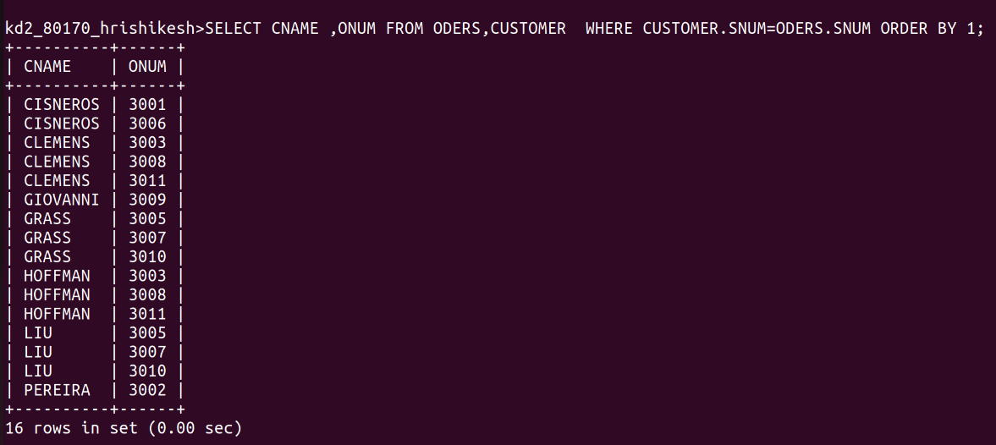
A
Q2 WRITE A QUERRY THAT PRODUCE THE NAMES AND RATING OF ALL CUSTOMER WHO HAVE ABOVE AVERAGE ORDER

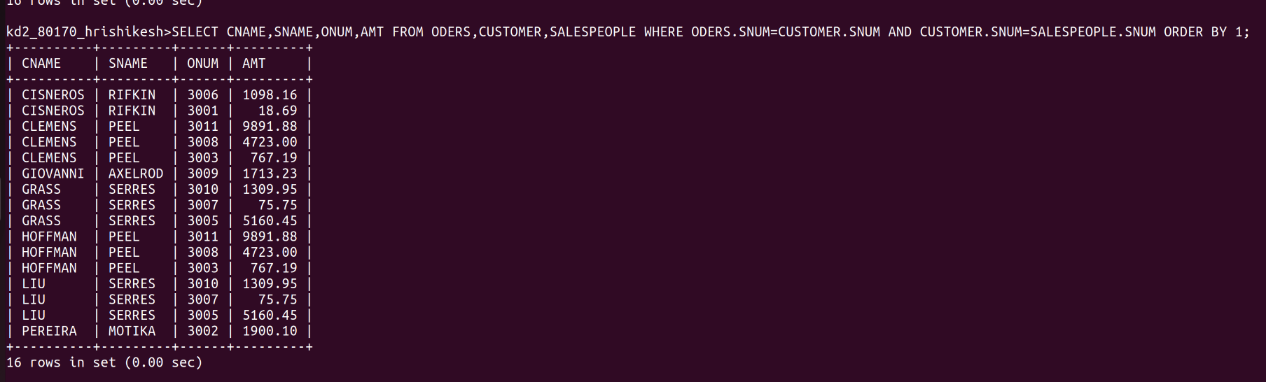
E

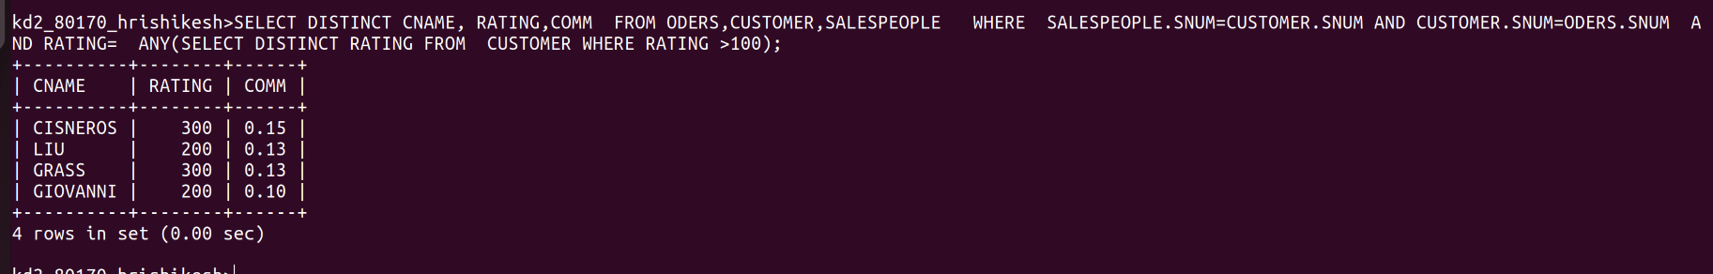
Q3 WRITE QUERY THAT PRODUCE ALL CUSTOMERS SERVICES BY SALESPEOPLE WITH A COMMISION ABOVE 12% OUTPUT THE CUSTOMER S NAME THE SALESPERSONS NAME, AND SALES PERSON RATE OF COMMISION

Q 4 WRITE A QUERY THAT CALCULATES THE AMOUNT OF THE SALEPEOPLE COMMISION ON EACH ORDER BY CUSTOMER WITH A RATING ABOVE 100

